Note: Include this page only when adding / amending / deleting a document. If using this document as a record, this Revision History page can be omitted.

REVISION HISTORY

Revision no | Date | Description of Changes | Reason for Revision | Revised by | Approved by
2 | 01 June 13 | Add revision history page | - Recommendation from Stage 2 audit | RDPlacido
3 | 8 Apr 16 | Added disclaimer when printing the document | For document control | RCGanal | MVBergantin
4 | 5 Mar 18 | Removed Movement Tracker  Removed EMS  Removed PE returns monitoring  Added Employee Masterlist | -Document not being used  - No existing database / not being used  -Document already deleted from the list of documents  -Added in replacement to EMS | JGAdra
TM-BR-MG- 11 Rev02, 10302015

I. Objective
To identify and process the transfer and/or promotion of employees based on the assessment of their supervisor on technical skills, work attitude and potential. To process the transfer of the employee to another project smoothly.
II. Scope
This procedure defines the action and responsibilities of the HR Head, Unit Heads and Account Managers in processing the employee movement. This covers activities from the Performance Evaluation Process to endorsement to appropriate training.
III. Definition of Terms
Movement Letter | Letter of Appointment given to the due to employee lateral transfer of position/project, merit, promotion or regularization.
Deployment Letter | Is a letter given to the employees to be deployed to the client site specifying the reporting details.
Employee History Card | Records the movement of employees in terms of position and salary.
Movement Report | - Is a two part report. Part I shows the schedule of the movement of the employee relating to regularization, merit and promotion. It also shows the status of the movement if it already processed or not.  - Part II reports the common reasons why employee services are terminated by the Unit Head / Account Manager / Client Supervisors. This part is presented to ManCom every end of the year.

- Procedure Details
RESPONSIBLE | ACTIVITY | INTERFACE
HR Head  HR Head Unit Heads / Account Managers | 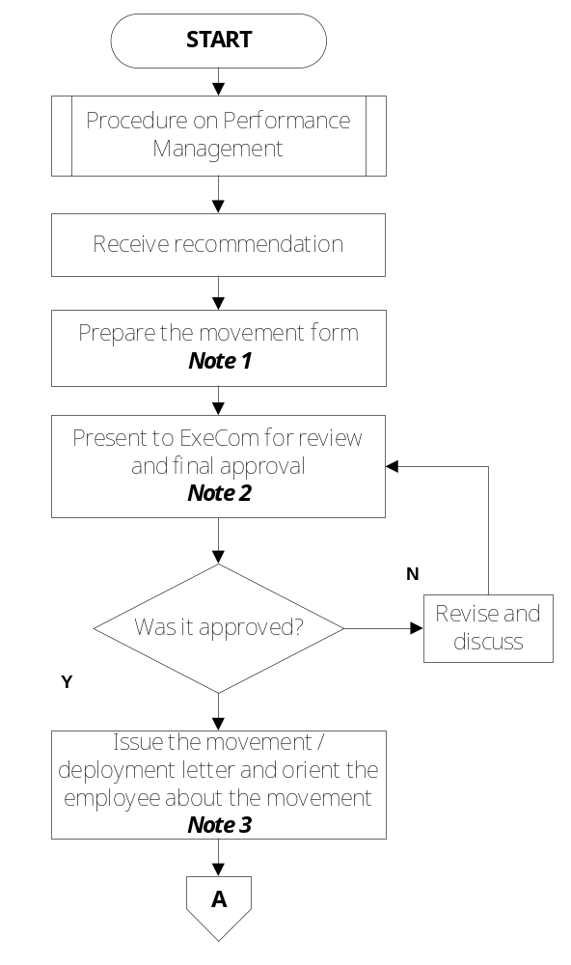 | Procedure on Performance Management  Guidelines for Employee Movement Report Recommendation Unit Head / Client  Movement Form  ExeCom  Movement Form  Guidelines for Employee Movement Movement Forms Project Clearance Form Movement Letter Deployment Letter
RESPONSIBLE | ACTIVITY | INTERFACE
HR Head | 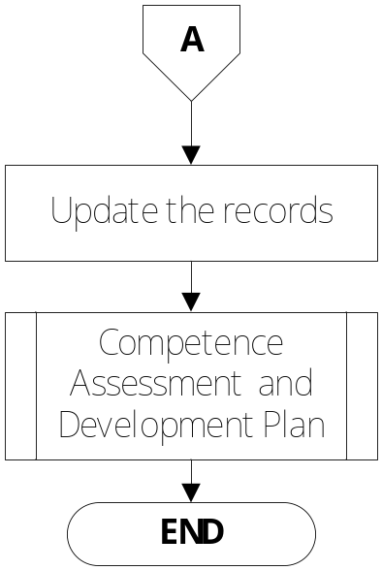 | Performance Evaluate History Card Employee History Card Employee Masterlist  Competence Assessment and Development Plan

Notes:
- New Unit Head / Account Manager of the transferring employee, with HR Head, will provide description about the new position, project or unit or any change in the policy / practices concomitant with the change of position / assignment.

- ExeCom will review and approve the correctness of the details in the Movement Form.

- Movement Letter will be given by the Unit Head. For bodyshop employees, it will be sent through the Communications Delivery Staff.
For deployment, Deployment Letter will be issued by the HR Head and Account Manager will give brief information about the project / client.

- References
- Movement Form
- Project Clearance Form
- Performance Evaluation History Card
- Employee History Card
- Procedure on Performance Management
- Procedure on Competence Assessment and Development Plan
- Guidelines for Employee Movement

- Quality Records
- Accomplished Performance Evaluation Form
- Filled-Out Movement Forms
- Signed Project Clearance Form
- Recommendation Letter
- Movement Letters:
  - Regularization
  - Merit Letter
  - Promotion Letter
  - Appointment Letter
- Deployment Letter
- Updated Performance Evaluation History Card
- Updated Employee History Card
- Movement Report
- Employee Masterlist

